**IMB’s Marketing Report**



**Module Name:   
Module Code:**

**Module Leader:**

**Student Name:**

**Student ID:**

**Word Count:** 3205 Words

**Date of Submission:**

**Executive Summary**

This integrated report is solely devoted to IBM's marketing strategy, which covers different crucial parts, including IBM's profile, marketing environment, integrated marketing communications and the fusion of online and offline media. The analysis has honed some vital knowledge of the strategies used by IBM to understand the challenges of the fast-evolving technology sector. IBM's company profile reveals its foundation year, size, and significant milestones that are instrumental in labelling it as the foremost technology giant globally with a long history of ground breaking inventions and prosperous leadership. In addition, the paper focuses on the segment in which IBM works, highlighting the industry in which tech companies operate and the long-term goal of continuously incorporating advanced technologies into business development and innovation.

Proper investigation of the marketing environment, which includes social, technological, and sustainability aspects, brings important information about the external circumstances that might influence IBM's marketing strategy. This scrutinization clearly illustrates the importance of developing business strategies that adapt to society quickly by using the latest technologies and pursuing sustainability. The report goes into IBM's integrated marketing communications framework. It covers the sections on advertising, sales promotion, and direct and digital marketing. This section critically reviews how IBM has been integrating these tools to engage consumers, intensifying the moment of providing personalized and relevant information across all communication channels.

Besides that, utilizing online and offline media has become essential for IBM's brand strategy, making a seamless brand experience and connecting with its audience. Using data analytics and customer insights, IBM can use targeted messaging to enhance performance across digital or traditional media (Cavlak and Cop 2021). The analysis also offers insight into IBM's marketing decisions and the impact of data analytics on shaping these decisions. This emphasizes the company's efficiency in harnessing data-based understandings to underpin marketing strategy, boost performance, and generate outcomes. Nevertheless, obstacles like generating uniformity and achieving the greatest return on investment remain significant issues that underline the congruent need for continuous enhancement.

This report provides a detailed analysis of IBM's marketing strategy, which can be proven useful in treading the uncharted waters of the fast-transforming business world of information and communication technology. By adopting innovation, data analytics, and the practical use of online and offline media, IBM will be prepared to facilitate business growth and deliver value to customers in a rapidly changing market environment.

**Table of Contents**

**Introduction** 4

**Company Profile** 4

**Marketing Environment - Digital Marketing Environment Analysis** 5

Micro-Environment Analysis: Porter's Five Forces analysis 5

Customers 5

Competitors 5

Suppliers 5

Macro-Environmental Analysis: SLEPT Analysis 6

Social/Cultural Factors 6

Technological Factors 7

Sustainability Factors 7

**Integrated Marketing Communication** 8

DRIP model 8

Differentiate 8

Inform 8

Persuade 8

Advertising 9

Sales Promotion 9

Direct and Digital Marketing 9

**Integration of Online (Digital) and Offline (Traditional) Media** 10

**Conclusion** 11

**Reference** 11

# Introduction

This report studies the IBM Company, which has managed to deal with problems and remodel its business model to stay up to date with the rapid changes in the market. This evaluation aims to expose the main aspects of IBM's strategic repositioning, which comprise its profile, the general background of the modern marketing environment in which the company operates and the techniques of integrated marketing communication. We will explore how IBM has successfully used online (digital) and offline (traditional) media to increase its market growth and boost customer interaction with the company. The source intends to deliver a detailed overview of the factors that led to IBM's revival and rehabilitation in the technology industry by analysing.

# Company Profile

International Business Machines Corporation (IBM), generally known as "Big Blue," started as a firm specializing in the manufacture, sale, and repair of myriad electronic devices that may be used in a range of industries, formerly known as Computing-Tabulating-Recording Company (CTR). By 1924, IBM had taken on its present name, and its world headquarters were in Armonk City, USA (Hart 2007). It has offices in 175+ countries worldwide and employs more than 282,200 people. The organization is a pioneer of multiple technologies, such as cloud computing, artificial intelligence (AI), and quantum computing, among others, in various areas.

The IBM businesses are organized into the Data Analytics, Advisory, Infrastructure, and Finance segments (IBM 2021). The Software segment helps develop and implement solutions that blend hybrid cloud and AI platforms. The consulting segment includes a broad range of industries where the company uses strategy, technology, and operations skills to integrate industries. The infrastructure business segment provides customers with the hardware needed for cloud-based and on-premises systems. In contrast, in the Financing business segment, IBM and third-party hardware, software, and services can be financed by IBM.

IBM owns an impressive and robust technological industry; this corporation was the number one patent holder for the most extended years from 1993 to 2022. It is one of the companies that introduced technological innovations such as the automated teller machine (ATM) and the floppy disk in its history, being the first to develop dynamic random-access memory (DRAM) technology (Aditya Shastri 2021). Moreover, the company plans to become carbon-neutral worldwide by 2030, eliminating its contribution to climate change.

According to data and analytics skills, IBM's ability can be observed on the skill pyramid at the very top level. Through big data analytics, the organization competes across its business lines on innovation, primarily enabled by its AI and hybrid cloud solutions, which improve the clients' efficiency and agility in digital transformational endeavours (Dash et al. 2019).​ The vivid spectrum of operations and devotion to innovation contains the essence of IBM and its leadership in the technology sector, being the driving force that moves the technologies of tomorrow to our doorsteps today.

# Marketing Environment - Digital Marketing Environment Analysis

A marketing environment is the set of all internal and external elements that impact how a company develops and implements its marketing strategies and operations (Olexova and Gregova 2020). Understanding the marketplace wroks can be very important as it helps a firm comprehend the variables that can influence its marketing strategies and, hence, gives room for adjusting the plan to cater to customer needs better and ensure competitiveness.

## Micro-Environment Analysis: Porter's Five Forces analysis

### Customers

Every customer is a primary market force that determines the business's mode of operation, especially in an industry like technology, where their preferences and finances affect the supply chain and demand curve. In the UK, the technology area has been the resilient consumer spender, though some pressures have characterized the broader economy. For example, it may have been the reason for the slighter decline in overall consumer spending in some areas. However, the IT sector has been provided with more opportunities for investment in cloud storage, cybersecurity, AI, and automation. The verticals are perceived as the critical components for advancing operational efficiency and workforce squeeze, wherein IT spending is expected to rise by 8% in 2024 (Nagel 2023).

Thus, consumer behaviour in the UK indicates a balanced pessimism wherein although consumer spending decreases on average, a recovery movement has been seen in particular areas of technology consumption (Isabelle, Stenstrom and Kim Örnbratt 2023). The long-term rebounding of technology spending is partly owed to customers' recognition of the value and need for technology in contemporary lifestyles, requiring business strategies to be adjusted to match consumer expectations and the economic context.

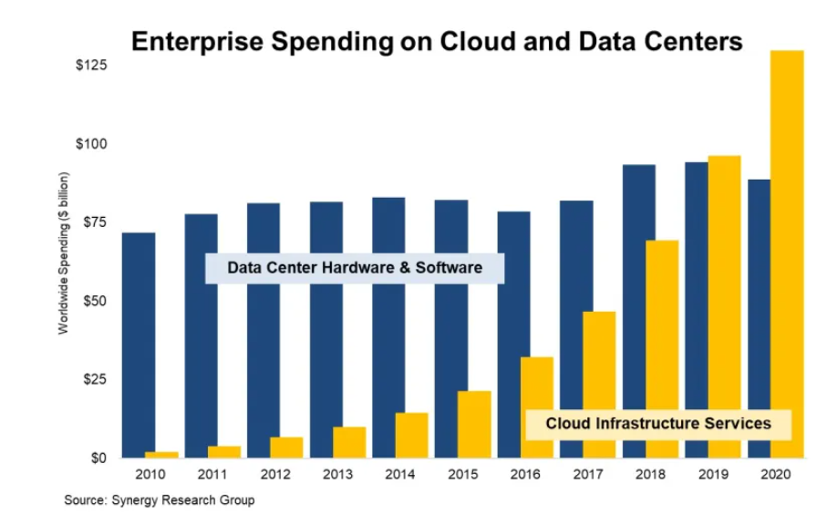

**Figure 1 – showing increase in IT spending in Cloud and date centre due to customer demand**

**Source - (Miller, 2021)**

### Competitors

IBM's competitive environment is full of the largest global tech companies that offer services and products. Notable competitors are Microsoft, Google, and Oracle, and most of them cater to cloud computing, artificial intelligence, and enterprise IT services, such as IBM (Azam 2020). An argument for selecting these only three companies is that they hold the largest market share, broad product portfolios, and strong moves within cloud and AI areas that affect IBM significantly.

Take Amazon and Microsoft, for example; they have enhanced their market positions by providing a whole spectrum of robust business offerings in terms of cloud infrastructure, which also remains of much importance to IBM's enterprise service side.

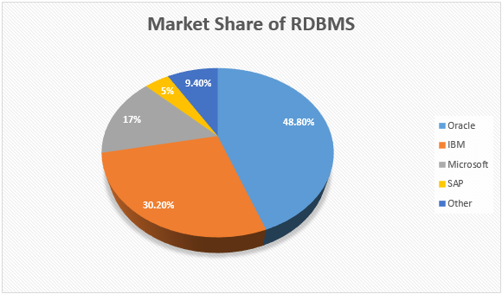

**Figure 2 – IBM’s market share compared with competitors**

**Source- (Browns, 2016)**

### Suppliers

Suppliers hold the key in IBM's operations for supplying critical hardware components, software solutions, and support services that are crucial to IBM's offerings to its customers. IBM's supplier partnerships are integral in the production of high-quality and innovative products in environments such as technology and consulting that are dynamic and competitive.

The role of suppliers for IBM is vast, ensuring the company satisfies customers with its quality products (Kalir and Grosbard 2017). Likewise, the semiconductor industry suppliers are critical players since they provide the advanced components used in developing IBM's cloud data centres and AI applications, which affect the product's performance and impact the company's competitiveness. Those equipment supplier stability and reliability relationships are significant for maintaining IBM's overall operating efficiency and innovation capacity.

## Macro-Environmental Analysis: SLEPT Analysis

SLEPT is a comprehensive analysis tool used to study external environmental elements that affect an organization, including Socio-cultural, Legal, economic, Political, and Technological factors (Ortiz 2010). This approach enables organizations to comprehend the macro environment's external forces that could affect their operations and strategic calculations.

Therefore, the SLEPT approach is essential for businesses as it allows them to use a structured method of strategically analyzing how the outside environment poses a threat or an opportunity. By examining these dimensions, organizations can see these changes to come and adjust their strategies accordingly, and thus, they can appropriately react to the dynamic market conditions. As such, the proactive assessment properly frames the business strategies within the external environment, and therefore, risk management becomes effective, and opportunities are tapped.

### Social/Cultural Factors

The social and cultural components of the SLEPT analysis comprise the changes in the population structure, the growing trend of consumers, and their behaviour, which directly determine IBM's strategic direction. With the world population ageing and people aged 60 and over amounting to almost 12 per cent of the world's population, there is a growing demand for technology which caters to older people of age; hence, technology becomes user-friendly and accessible (Lee 2022). Additionally, increasing the education levels globally improves the human resources skillset, allowing IBM to enjoy a better-trained workforce base for more knowledgeable research and development. Adapting to these social transformations activates IBM to create flexible marketing strategies and product development that respond to the requirements of different company customers, wherein relevancy and sustainability in the existing product range are guaranteed.

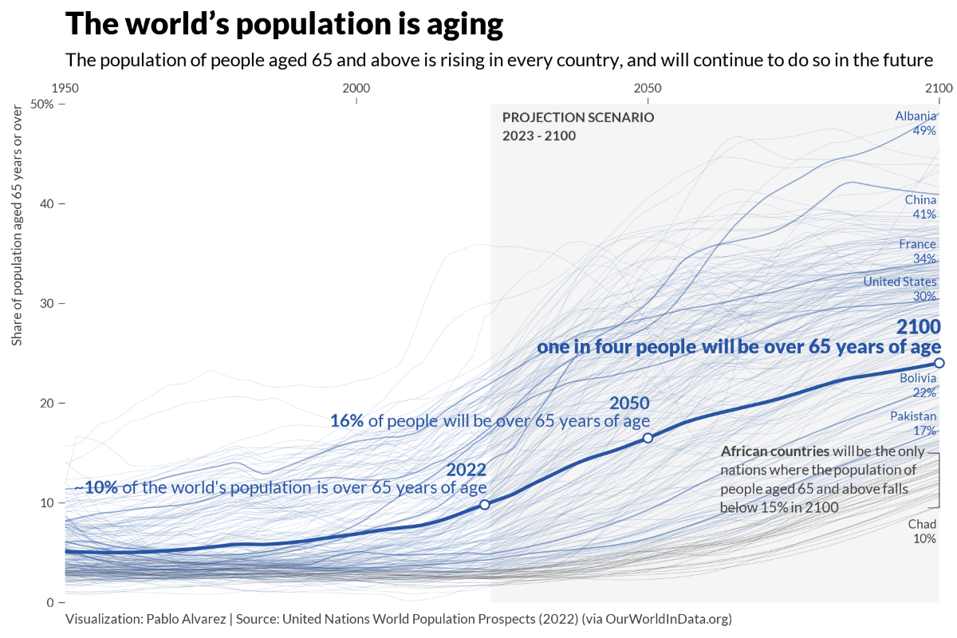

**Figure 3 – showing Global Population Aging**

**Source - (Alvarez, 2023)**

Consumers are becoming more aware of how businesses operate. They are choosing highly ethical companies & copy such motion forces firms such as IBM to address CSR and moral aspects of business in full view and their future policies. For instance, IBM attracted qualified staff and customers with programs that aim to increase women in technology and improve minority representation (IBM 2020). It successfully safeguarded its image as a giving company at the same time. Comprehending social structures and values helps IBM converge its scattered values with its stakeholders, strengthening its loyalties and improving its edge over competitors in the technology sector.

### Technological Factors

Technological elements are the major factors determining the future of any firm operating in an area as fast-paced as the tech world. The last part of the SLEPT analysis involves the analysis of the technology change rate, technological diffusion, and R&D level of intensity in the industry. IBM's quest for innovation is one thing that will help the company pull out a competitive edge above other tech organizations where innovation is made possible in AI, quantum computing and block chain (Cortada 2018). Besides, the company's leadership in technological innovation is not only this fact; it is also about the revenue stream that comes with better solutions for the market or individual customers and eventually enables the company to stay on top of the game.

Aside from that, adopting technology in business procedures and many industries within the corporation has brought both prospects and problems for IBM. This leads to an increasing number of businesses, such as cloud services, cybersecurity solutions and artificial intelligence applications, frequently clamouring for demand. Through its strategic investments in these fields, IBM has developed solutions that are integrated with various customers' needs.

### Sustainability Factors

As IBM competes with more companies, including those with greener products, environmental issues and the international call for sustainability drive IBM to consider the environmental impact of its business operations (Lenssen and Smith 2018). Better supply chain management, product creation, and marketing can improve its data centers' energy efficiency and waste reduction, which may benefit the client. IBM has become an environmental corporate responsibility leader by offering "greener" technologies and partnering with sustainable companies and organizations.

Environmental regulations also require IBM to make changes that present risks and opportunities. The introduction of global emissions, waste, and resource consumption standards forces IBM to rethink its internal business practices, which may initially increase costs. These reforms also offer business opportunities to shape products and services, helping other industries achieve sustainability. IBM can use its AI and analytics expertise to create resource management solutions that exceed regulatory requirements and create sustainable business opportunities.

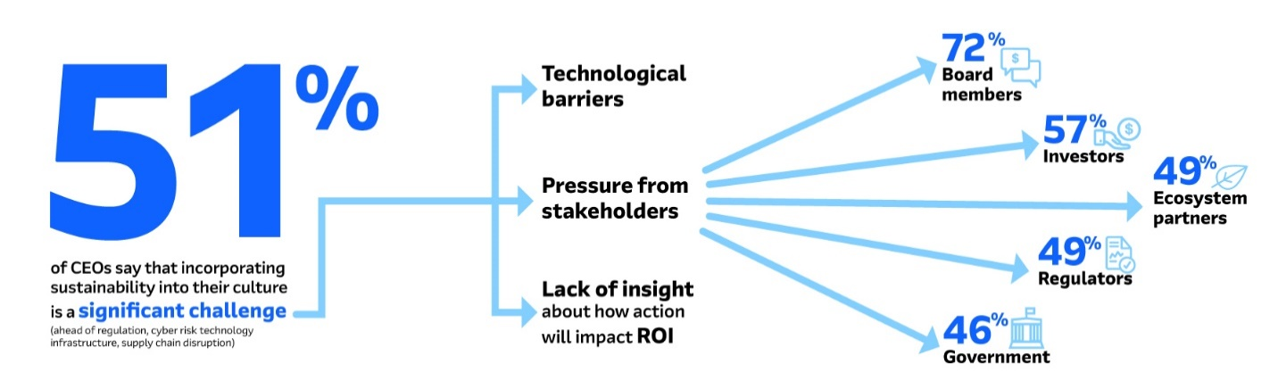

**Figure 4 - (Source: IMB)**

# Integrated Marketing Communication

Integrated Marketing Communication (IMC) is a strategic and comprehensive approach that coordinates diverse promotion tools and communication channels so that the messages provided to the target audience are clear, consistent and more robust (Camilleri 2017). It presents an approach that, in addition to promoting facilities, others the communication and of several departments which in this way can work together. The main implication of the IMC is what it does to the branding tactic as it unifies the message across all the marketing channels, thus adding up to the marketing efforts. Consistent messaging delivery of a brand through all the platforms of IMC helps businesses improve their brand presence, engage more customers, and achieve better marking results, thus creating more sales and customer loyalty.'

## DRIP model

In implementing the DRIP model for IBM's marketing communication mix, three critical elements can be emphasized: Differentiate your business, enlighten your customers and convince them to purchase your products/services (Singh and Birdi 2011). Each performs the primary function of increasing its presence in the ICS market and successfully communicating with the target audience.

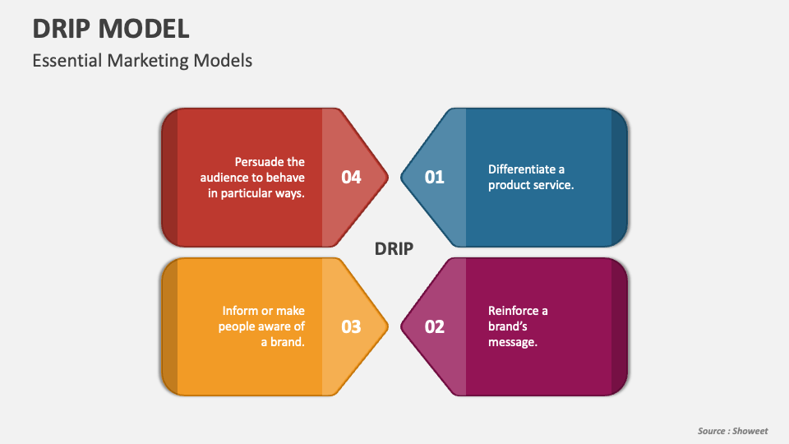

**Figure 5 – Source by Showeet**

### Differentiate

By promoting its specific features and best practices, IBM can take a sustainable competitive advantage. Companies like Google and Amazon are focused on speed and offer other services along with computing power. IBM's differentiation strategy concentrates on IBM being different from competitors which involves the consumer inclination towards the unique selling proposition of IBM and innovative solutions from IBM as per customer requirements (A. Islami and Topuzovska Latkovikj 2020). Case in point, IBM's quantum computing achievements can be featured as the best in the sector. Above all, this improvement provides solutions for the data problem that traditional computers will fail to solve.

### Inform

One of the distinctive features of the IBM DRIP model is public relations, which is very important for educating the market about IBM product offerings and its technological advancements. It contains comprehensive interaction covering the proposed product's features, benefits and anticipated applications (Shaik 2022). Hence, IBM could generate more blog entries and webinars and display them at techy events, providing the product's specifications and intended applications. Apart from exposing customers to the functionalities and benefits of IBM's solutions, this strategy also nurtures a savvy customer base that goes beyond the understanding of how technology can significantly drive operational productivity.

### Persuade

At the last stage of the communication model, this is when there is an attempt to persuade customers to adopt more behavioural changes and build more relationships with a brand. Using evidence of positive efficiency, speed, accuracy, and reliability, IBM can use persuasive communication to convince clients to change their ideas. An approach example entails utilizing case studies or customer testimonials which detail the implementations of IBM technologies as some persuasion means. Furthermore, promotions and trial campaigns can be implemented to increase the number of people trying IBM products. In return, the decision about the purchase will be made in favour of IBM.

## Advertising

IBM, however, uses various global advertising strategies throughout the digital and traditional media to promote its products and services, ensuring the end consumer is well aware of the existence and quality of its products and services (Zwier 2021). Similarly, one of the strategies IBM uses is spending vast sums of money on advertising campaigns on various platforms such as TV, print media and online channels. These platforms are then used to raise awareness about brands and to reinforce the notion that IBM is reliable in technology solutions. Besides traditional advertising, IBM utilizes purpose-tailored digital mediums to reach specific audience segments, using data analytics and AI models to promote ads and tailor messages. E.g. the "Smarter Planet" campaign developed by IBM in 2008 was a marketing strategy intended to showcase IBM's technology solutions, such as healthcare, transport, and energy management that can be implemented to solve societal problems (Söderström, Paasche and Klauser 2014). It was a multidimensional campaign incorporating TV ads, online promotional advertisements and a solid social media presence to reach the global audience.

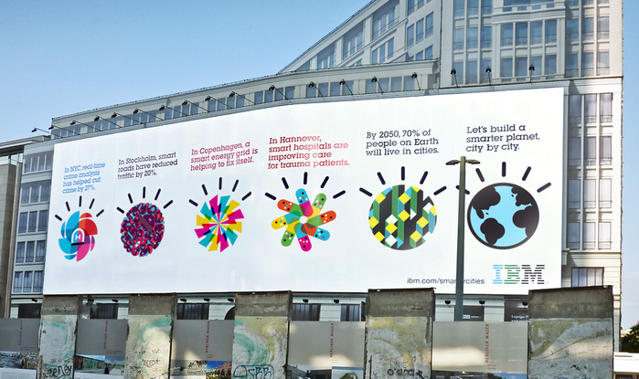

**Figure 6 – IBM’s Billboard showing its “Smarter Planet” Campaign**

**Source- (IMB, 2008)**

## Sales Promotion

By IBM, the sales promotion tactics are used to provide the customers with an incentive to buy goods and give a push to short-term sales, which are also supported by the marketing campaigns. Another sales promotion strategy that IBM implements includes having limited-time offers of discounts or special pricing.' For instance, IBM could offer promotional prices knocked down for its cloud computing services or software solutions during the promotion period as an incentive to draw in new clients and to motivate existing clients to migrate to higher price tiers. Moreover, IBM could provide package-and-value-added services to their sales promotion so customers would be more interested in purchasing their products. These sales promotions are commonly relayed through multichannel ways, reaching customers through email marketing, digital advertising, and direct outreach with sales for the customers' convenience.

## Direct and Digital Marketing

Marketing campaigns by IBM include direct marketing and digital marketing that bring customers together and communicate individualized sales messages designed for the particular needs and tastes of these customers. IBM regularly uses email marketing campaigns, enabling it to engage directly with customers to offer details on new product features, discounts, and other latest industry news (Sabbagh 2021). IBM's marketing channels include social media, search engine optimization (SEO), and content marketing. They are used to reach potential customers, attract them, and guide them in the sales funnel through lead nurturing. Another example is IBM's content marketing strategy, which entails publishing articles with thought leadership concepts, case studies, and whitepapers on its website and social media channels to educate prospects and build an image of an industry-leading body. By applying data analytics and marketing automation platforms, IBM can monitor customer interactions and behaviours while delivering real-time and relevant content and offers to buyers at various stages of the buying process, contributing to sales conversion.

# Integration of Online (Digital) and Offline (Traditional) Media

Through a comprehensive approach across platforms, IBM increased its target audience reach by integrating online and offline media channels. IBM uses social media, SEO, email, and content marketing to engage with customers quickly and deliver tailored messages. IBM posts industry knowledge, thought leadership, and product and service updates on LinkedIn, Twitter, and Facebook. The platforms are the company's best chance to connect with customers and build brand advocacy through digital engagement.

IBM uses traditional media like newsprint advertising, television commercials, and event sponsorships to supplement its online presence and reach a wider audience. IBM might publish print ads in industry publications or sponsor essential industry events to familiarize potential clients with its brand message and corporate reputation. IBM uses online and offline ads to keep its marketing consistent and on brand. IBM maximizes its impact with this Omni channel approach. It connects consumers at every customer journey touchpoint, helping businesses grow in this digital world.

IBM uses IT tools to monitor and optimize its real-time marketing campaigns. IBM measures its marketing effectiveness using KPIs like click-through rate, conversion rate, and ROI (Silva, Duarte and Almeida 2020). IBM can standardize database decisions after the assessment to adjust performance if needed. IBM's constant campaign updates allow it to respond quickly to market trends and customer needs, maximizing marketing effectiveness and company growth. With data analytics aligned with IBM's marketing campaign decisions, planning, efficiency, and marketing goals are met more effectively.

The IBM marketing strategy includes metrics to assess the company's social media efforts and KPIs to measure audience engagement, reach, and sentiments. IBM Talisman can analyze social media metrics to reveal customer preferences, behaviour, and sentiment, improving messages, content strategy, and customer engagement. IBM may use social media analytics to track trends, analyze competitors, and identify contextual creation or campaign refinement opportunities.

IBM can deliver a personalized and consistent experience by blending media channels, which moderates interactions and boosts brand loyalty (Shanahan, Tran and Taylor 2019). IBM can use customer insights and data analytics to provide personalized and relevant brand messages to meet each customer's needs and interests. The profession effectively creates a clan of happy and loyal clients and advocates because this special attention increases customer loyalty and brand goodwill. The overall use of media channels like social media analytics is critical to IBM's marketing strategy to maintain audience connections, attract engagement results, and meet business goals in a digital age.

# Conclusion

In conclusion, thorough research presented in this report shows several imperative components of IBM's marketing strategy and implementation. Analyzing the marketing environment with the social, technological, and sustainability issues reflects the necessity of keeping up with the changes and using the possibilities for growth. Whether IBM is using advertising, sales promotions, or even direct or digital marketing, the efficacy of integrated marketing communications is a testament to its ongoing commitment to engaging consumers at all touchpoints. Moreover, online media integration allows IBM to reinforce its brand and engage its audience by creating a unified brand experience. Although the firm managed to use data analytics to help develop marketing campaign choices, the task of maintaining harmony between different channels and increasing efficiency remains. Generally, IBM's strategic marketing method exhibits the corporation's ability to evolve while focusing on customers in a fast-changing and competitive business environment.

# Reference

A. Islami, X. and Topuzovska Latkovikj, M. (2020) *(PDF) Linking Porter’s generic strategies to firm performance* [Internet]. Available from https://www.researchgate.net/publication/338558709_Linking_Porter.

Aditya Shastri (2021) *Full Case Study on IBM Marketing Strategy & Competitors Analysis | IIDE* [Internet]. Available from https://iide.co/case-studies/ibm-marketing-strategy/.

Azam, A.G. (2020) A Review on Artificial Intelligence(AI), Big Data and Block Chain : Future Impact and Business Opportunities. *Global Journal of Management and Business Research* [Post-print], 20 (B10), pp. 23–33. Available from https://journalofbusiness.org/index.php/GJMBR/article/view/3246/3-A-Review-on-Artificial_html.

Camilleri, M.A. (2017) *(PDF) Integrated Marketing Communications* [Internet]. Available from https://www.researchgate.net/publication/319085740_Integrated_Marketing_Communications.

Cavlak, N. and Cop, R. (2021) The Role of Big Data in Digital Marketing. *Advances in Marketing, Customer Relationship Management, and E-Services* [Post-print], pp. 16–33. Available from https://www.researchgate.net/publication/353198312_The_Role_of_Big_Data_in_Digital_Marketing.

Cortada, J.W. (2018) Change and Continuity at IBM: Key Themes in Histories of IBM. *Business History Review*, 92 (1), pp. 117–148.

Dash, S., Shakyawar, S.K., Sharma, M. and Kaushik, S. (2019) Big data in healthcare: Management, analysis and future prospects. *Journal of Big Data* [Post-print], 6 (1), pp. 1–25. Available from https://journalofbigdata.springeropen.com/articles/10.1186/s40537-019-0217-0.

Hart, D. (2007) Red, White, and ‘Big Blue’: IBM and the Business—Government Interface in the United States, 1956—2000. *Enterprise & Society* [Post-print], 8 (1), pp. 1–34. Available from https://www.jstor.org/stable/23701111.

IBM (2020) *IBM 2020 Diversity & Inclusion Report* [Internet]. Available from https://www.ibm.com/impact/be-equal/pdf/IBM_Diversity_Inclusion_Report_2020.pdf.

IBM (2021) *IBM to Update Management System and Reporting Segments* [Internet]. Available from https://www.ibm.com/investor/articles/ibm-to-update-management-system-and-reporting-segments.

Isabelle, Stenstrom and Kim Örnbratt, E. (2023) *THE EVOLUTION OF TECHNOLOGY AND ITS EFFECT ON CONSUMPTION* [Internet]. Available from https://www.diva-portal.org/smash/get/diva2:1761099/FULLTEXT01.pdf.

Kalir, A.A. and Grosbard, D.I. (2017) Global Optimization of a Semiconductor IC Supply Chain Network. *Journal of Service Science and Management*, 10 (03), pp. 338–352.

Lee, C. (2022) Technology and aging: the jigsaw puzzle of design, development and distribution. *Nature Aging*,.

Lenssen, G.G. and Smith, N.C. (2018) IBM and Sustainability: Creating a Smarter Planet. *Managing Sustainable Business*, pp. 549–556.

Nagel, B.D. (2023) *IT Spending to Top $5 Trillion in 2024 -* [Internet]. Available from https://thejournal.com/articles/2023/10/19/it-spending-to-top-5-trillion-in-2024.aspx. [Accessed 30th April 2024].

Olexova, V. and Gregova, E. (2020) *(PDF) Importance and Process of Marketing Environment Analysis as Strategic Analysis Tool of Business* [Internet]. Available from https://www.researchgate.net/publication/347672234_Importance_and_Process_of_Marketing_Environment_Analysis_as_Strategic_Analysis_Tool_of_Business.

Ortiz, J. (2010) The global environment through the SLEPT framework. *International Journal of Business and Globalisation*, 5 (4), p. 475.

Sabbagh, F. (2021) *Email Marketing: the Most Important Advantages and Disadvantages* [Internet]. Available from https://www.researchgate.net/publication/356908731_Email_Marketing_The_most_Important_Advantages_and_Disadvantages.

Shaik, K. (2022) *Case Study of IBM* [Internet]. Available from https://papers.ssrn.com/sol3/papers.cfm?abstract_id=4301687.

Shanahan, T., Tran, T.P. and Taylor, E.C. (2019) Getting to know you: Social media personalization as a means of enhancing brand loyalty and perceived quality. *Journal of Retailing and Consumer Services*, 47 (1), pp. 57–65.

Silva, S.C. e, Duarte, P.A.O. and Almeida, S.R. (2020) How companies evaluate the ROI of social media marketing programmes: insights from B2B and B2C. *Journal of Business & Industrial Marketing*, 35 (12), pp. 2097–2110.

Singh, S. and Birdi, N. (2011) Effect of Drip Marketing on the Advertisement. *SSRN Electronic Journal*,.

Söderström, O., Paasche, T. and Klauser, F. (2014) Smart cities as corporate storytelling. *City*, 18 (3), pp. 307–320.

Zwier, S. (2021) Insurance-based marketing (IBM): a prevalent marketing strategy. *Journal of Financial Services Marketing*,.

Alvarez, P. (2023). *Charted: The World’s Aging Population from 1950 to 2100*. [online] Visual Capitalist. Available at: https://www.visualcapitalist.com/cp/charted-the-worlds-aging-population-1950-to-2100/.

Browns (2016). *Competitors*. [online] margaretherzfeld.weebly.com. Available at: https://margaretherzfeld.weebly.com/competitors.html [Accessed 23 May 2024].

IMB (2008). *IBM – Office Jason Schulte Design*. [online] Jason Schulte Design. Available at: http://visitoffice.com/work/smarter-planet/ [Accessed 23 May 2024].

Miller, R. (2021). *Cloud infrastructure spending passed on-prem data centers in 2020*. [online] TechCrunch. Available at: https://techcrunch.com/2021/03/19/cloud-infrastructure-spending-passed-on-prem-data-centers-in-2020/.